
WORLD QUARANTOUR

An immersive journey around the world from your home

This is the longest I have gone without traveling in the last 25 years. And I don’t like it. SO, I am leaving now and I invite you to join me. We will literally travel around the world, one stop per continent. As I always do, I will prepare you for the journey with resources and provide insights from my lifetime of travel to 150 countries and all states and continents. Because they say travel will start closer to home, we will start in the US and go from there. I hope you enjoy the journey and feel free to share it with friends who may also have cabin fever.

Linda de Sosa
Bucketlist Travel Consulting,
independent affiliate of Travel Experts, a proud member of Virtuoso.

lindadesosa@ travelXperts.com 2814601090




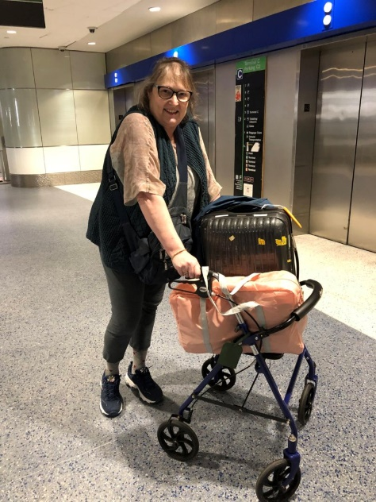
Prepare for stop one, the US National Parks
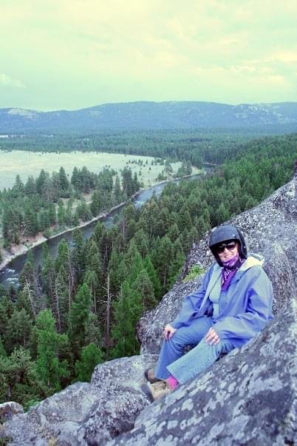
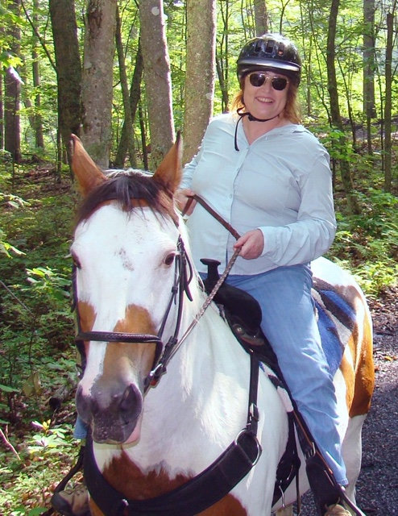
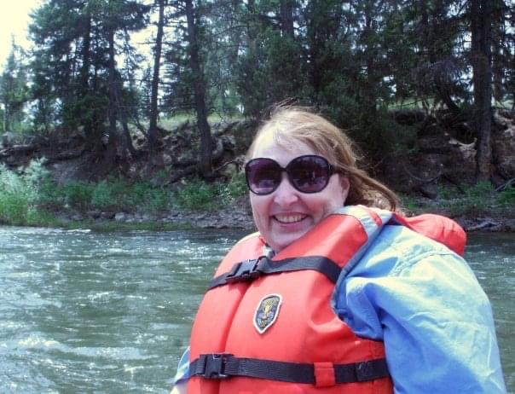
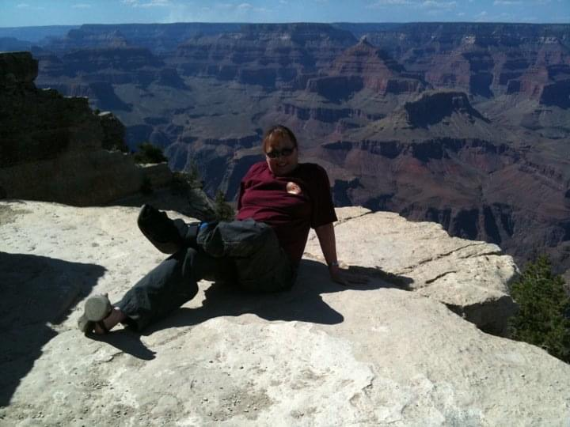
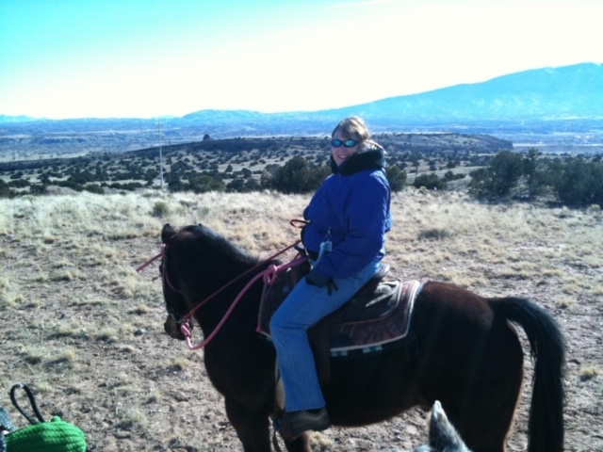
There are 61 US National parks, each one exhibiting some wonderful scenery. This is separate from the 52 and 89 National Historic Parks and Sites, respectively. You may be surprised at the most visited park – which is Great Smokies National Park. National parks can

seen by walking, hiking, rafting, driving or on horseback. As you can see from my pose by the Grand Canyon with my broken ankle in a boot, you do not have to be fully mobile.
Movies to get you in the mood
https://www.nationalparks.org/connect/blog/ready-set-action-your-national-parks
https://www.outsideonline.com/2083381/they-look-great-screen
A little light reading to get you in the mood
Lists
https://bookriot.com/2016/08/18/100-must-read-books-national-parks/

https://www.travelandleisure.com/culture-design/books/best-national-park-books

Links to my favorites (please note that I may receive compensation for these though that does not affect my inclusions)

Your Guide to the National Parks: The Complete Guide to all 59 National Parks (Second edition)
https://amzn.to/2XcGQuo

100 Parks, 5,000 Ideas: Where to Go, When to Go, What to See, What to Do
https://amzn.to/2XjVAYm

National Geographic Guide to National Parks of the United States, 8th Edition (National Geographic Guide to the National Parks of the United States)
https://amzn.to/2Xjst7P

Learn about the wildlife
https://www.10best.com/interests/outdoor-adventures/10-incredible-animals-that-live-in-us-national-parks/

https://www.goodhousekeeping.com/life/travel/g4213/50-stunning-animals-from-our-national-parks/

http://www.thegreatestroadtrip.com/extras/2017/3/2/from-grizzlies-to-gators-americas-national-parks-are-holding

Learn about the culture
Given this is the wild, I looked at the cultures that frequently surround our parks, that of the Indians.
https://www.culturalsurvival.org/publications/cultural-survival-quarterly/american-indians-and-national-parks

Learn the language
Assuming you speak English, but not wolf, here is a guide.
https://www.livingwithwolves.org/about-wolves/language/

OK, ready for your trip from home? When you are…

Put on some music
https://youtu.be/cZ5FVLBUvfc

https://www.nationalparks.org/connect/blog/songs-share-love-national-parks

https://www.nps.gov/subjects/music/index.htm

Cook up some recipes
https://www.nationalgeographic.com/travel/travel-interests/food-and-drink/specialty-food-national-parks/

Now, here are some Virtual tours
https://www.nps.gov/subjects/npscelebrates/find-your-virtual-park.htm

If you enjoyed that, here are possible actual tours when the time to actually travel again arrives
First, where should you go?
https://www.travelandleisure.com/trip-ideas/national-parks/how-many-national-parks-are-there

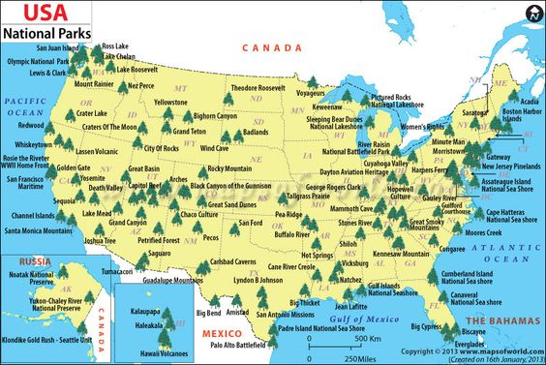

Types of tours
Of course, I would love to help you book these.

Adventure
https://www.backroads.com/tours/national-park-vacations

Wildlife focus
https://www.nathab.com/us-national-parks-tours/

Basic
https://www.caravan.com/tour/usa-mount-rushmore

https://www.caravan.com/tour/usa-grand-canyon

More deluxe
https://www.tauck.com/tours/american-canyonlands-grand-canyon-escorted-tour

https://www.tauck.com/tours/legends-american-west-national-park-escorted-tour?tcd=jh2020

Child focused
https://www.tauck.com/tours/wyoming-family-vacation-packages-to-cowboy-country?tcd=yyn2020

On your own
https://www.travelpulse.com/videos/car-rental-and-rail/amtrak-vacations-national-parks.html

Curated resources to help you further prepare
https://explore.approachguides.com/45/6226/R76t7ELg?uid=QXSBGbD5

Linda de Sosa
Bucketlist Travel Consulting,
independent affiliate of Travel Experts, a proud member of Virtuoso.

lindadesosa@ travelXperts.com 2814601090

Prepare for stop two, Spain

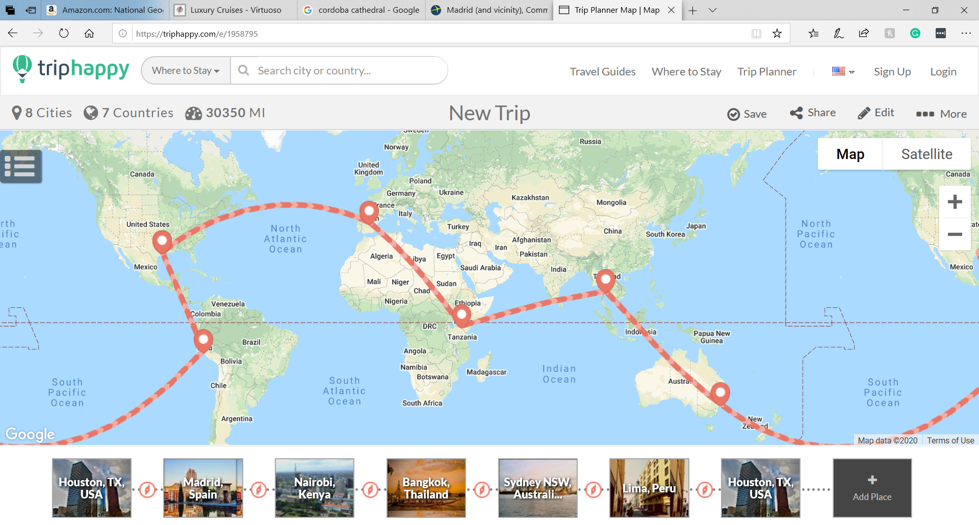

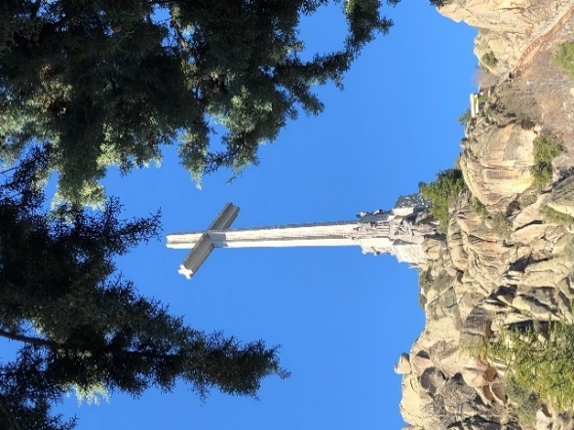
Spain has a very diverse history. Jews and Christians lived side by side. And then, the Moors swept across Northern Africa and into Spain. Many resources focused on keeping the Muslims from taking over the entire country. The Spanish finally reclaimed their land in 1492, which freed up their money to fund Christopher Columbus to go west.
The Islamic influence is very obvious in the South, especially in Grenada, where they built their capital at the Alhambra. Further evidence appears in Cordoba and Seville.
Modernism advanced in Barcelona and later Bilbao. Gaudi led the movement, as evidenced in La Sagrada Familia, Casa Battlo, and Casa Mila. Other creatives focused on art, including Picasso and Salvador Dali.
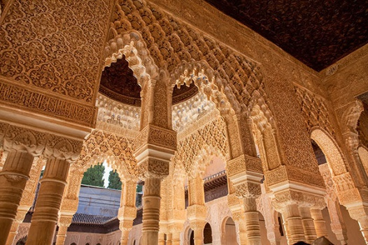
Food and wines are other attractions.

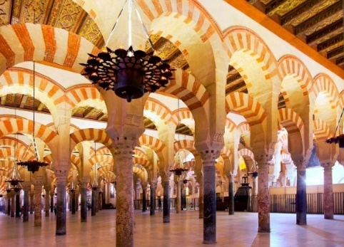
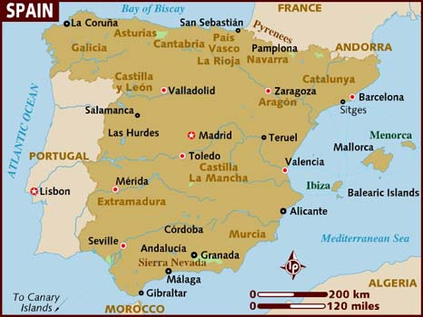

More photos to get you in the mood
https://www.nationalgeographic.com/travel/destinations/europe/spain/beautiful-photos/

Movies to get you in the mode
http://www.tasteofcinema.com/2015/10-great-english-language-films-to-help-you-discover-spain/

https://theculturetrip.com/europe/spain/articles/10-films-that-tell-you-about-spains-culture/

A little light reading to get you in the mood
https://www.tripfiction.com/ten-great-books-set-in-spain/

https://www.alternativetravelers.com/25-books-about-spain/

https://www.thelocal.es/20200318/ten-books-that-tell-you-everything-you-need-to-know-about-spain

https://www.theguardian.com/travel/2020/may/12/10-best-novels-set-in-spain-hemingway-cervantes

Links to my favorites (please note that I may receive compensation for these though that does not affect my inclusions)

Iberia by James Mitchener
https://amzn.to/2z8tsQd

Don Quixote
https://amzn.to/2AG1wmS

The Sun Also Rises by Ernest Hemingway
https://amzn.to/2ZiLABs

The Basque History of the World
https://amzn.to/2Zn93Br

Late Dinner: Discovering the Food of Spain
https://amzn.to/2ylobnV

Spain's Basque region celebrates local ingredients and a low-fuss style of cooking that shows them off. San Sebastian-based chef and writer Marti Buckley’s Basque Country: A Culinary Journey Through a Food Lover’s Paradise shares the origin stories of beloved traditional meals, a glossary of dialect slang, and, of course, recipes. (Start with the pan-fried trout stuffed with salty Serrano ham).
https://amzn.to/3etVtAr

Learn about the culture
https://www.donquijote.org/spanish-culture/

Within Spain, the Basque movement is very unique. You can focus on it in the North.
https://medium.com/@orge/behind-the-basques-the-most-misunderstood-culture-in-europe-beef2a373bb0

Spain’s Got Talent
Christina Ramos is my favorite contestant – one of the best in the world.
https://youtu.be/l3Yf_ErkN_s

Learn the language
https://www.thoughtco.com/online-spanish-classes-1098124

OK, ready for your trip from home? When you are…

Put on some music
https://youtu.be/wPJPmHSxKFc

Cook up some recipes
https://www.bbcgoodfood.com/recipes/collection/spanish

Take some virtual tours
https://www.alhambra.org/en/virtual-tour-alhambra.html
https://www.youtube.com/watch?reload=9&v=WVcqv-KfmDY
https://www.st-christophers.co.uk/travel-blog/virtual-tour-of-barcelona
https://vimeo.com/36603599

If you enjoyed that, here are possible actual tours when the time to actually travel again arrives.
Of course, I would love to help you book these.

Good introductory tour
https://www.tauck.com/tours/spain-escorted-tour?tcd=ws2021&sg=True

Focus on Northern Spain
https://www.tauck.com/tours/northern-spain-escorted-tour

Customized tour illustrating some special experiences.
https://spain.madeforspainandportugal.com/wp-content/uploads/sites/5/2017/07/Web-Highlights-of-Spain.pdf

Cruise
Many Mediterranean cruises begin in Barcelona and go eastward. There are a few that spend more time in Spain, traveling between Barcelona and Lisbon, usually including the Canary Islands, which are owned by Spain.
https://www.rssc.com/cruises/VOY201102/summary

Curated resources to further prepare
Spain in General
https://explore.approachguides.com/45/2187/lNfYOU7y?uid=QXSBGbD5
Focus on Spanish architecture
https://explore.approachguides.com/45/329/JkDAU2rW?uid=QXSBGbD5

Linda de Sosa
Bucketlist Travel Consulting,
independent affiliate of Travel Experts, a proud member of Virtuoso.

lindadesosa@ travelXperts.com 2814601090

Prepare for stop three, Kenya

Kenya is in East Africa. Typically, travelers’ first African trips are to either East Africa or Southern Africa. Both have culture and wildlife. Since East Africa (Kenya and Tanzania) is where the great migration is, if people are heavily into wildlife, that is where they would focus. Southern Africa (South Africa, Botswana, Zambia, and Zimbabwe) has wildlife, but it may be more spread out and harder to find. The area makes up for that with interesting history, wine, and culture.

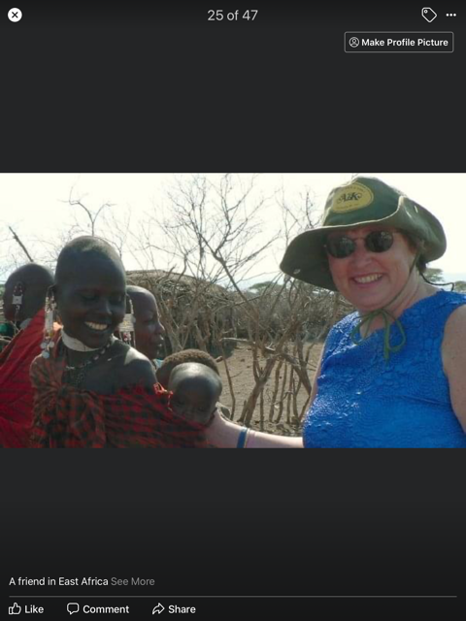
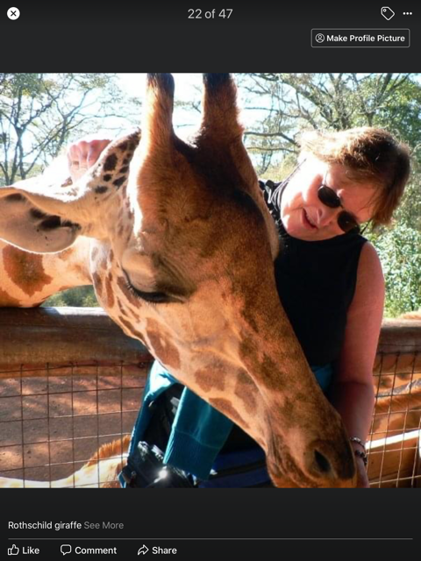

Movies to get you in the mood
http://www.siyabona.com/films-books-kenya.html

http://www.kenyatravelideas.com/moviesaboutkenya.html

A little light reading to get you in the mood
https://www.tripfiction.com/five-great-books-set-in-kenya/

https://theculturetrip.com/africa/kenya/articles/10-recommended-books-featuring-kenya/

Learn the language
Kenya was an English colony so it is wildly spoken. There are many tribal languages, but the Bantu language of Swahili has become a lingua franca so that they may understand each other.

https://www.fluentin3months.com/swahili/

Learn about the wildlife

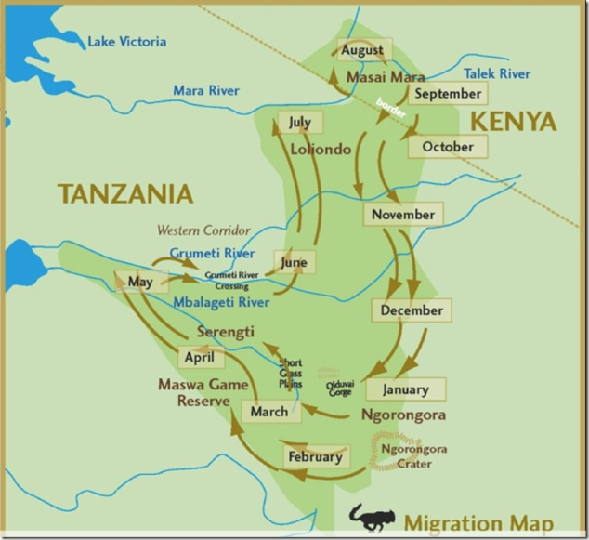
The great migration is the largest terrestrial mammal migration in the world. It takes place in two wildlife parks in Tanzania (Serengeti) and Kenya (Masai Mara), which are really one since animals do not recognize political borders. Millions of animals travel an endless giant circle following the rains and growing grasses. They are symbiotic in that one type of animal will eat one height of grass and another a different type. It includes zebra, wildebeest, and various antelope. They give birth on the run and face predators all along the route. Crocodiles inhabit the Grumeti River and big predatory cats are territorial so they wait for the migration to reach their home. The map here shows the approximate months were the animals traverse different regions.
https://www.abercrombiekent.com/travel-destinations/africa-safari/east-africa/kenya

https://isafari.nathab.com/countries/kenya

https://www.everyculture.com/Ja-Ma/Kenya.html

Learn about the culture
The people of Kenya are wonderfully friendly and you can visit their villages to learn more about their life. The Masai are the predominate people.
https://www.discoverafrica.com/safaris/kenya/cultural-practices/

http://maasaiwilderness.org/programs/ecotourism/?gclid=CjwKCAjwqpP2BRBTEiwAfpiD-8zoRdbZZ5yHzKFjjSfcQpilbq17aSg4Wrwakj0P_NXqXp2rXyim7BoC0H8QAvD_BwE

When you are ready for your home visit….

Put on some music
https://www.liveabout.com/kenyan-music-playlist-3553103

https://theculturetrip.com/africa/kenya/articles/music-genres-that-shaped-kenyan-music-through-the-years/

Cook up some recipes
https://delishably.com/world-cuisine/30-Foods-You-should-eat-in-Kenya

Virtual tours
https://www.porini.com/about-us/virtual-tours/

https://www.youtube.com/watch?v=1LlUWj7Br2M

https://www.youtube.com/watch?v=EPP36G3Z3l4

https://www.asiliaafrica.com/the-journey-s-worth-the-wait/safari-at-home/

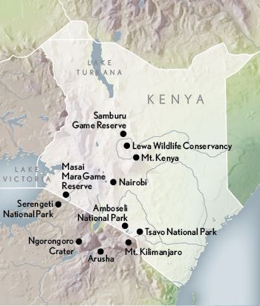
Here are some possible tours when the time to actually travel again arrives
I would be privileged to book them for you with my special contacts.
When you go to Africa, you will want to go to several parks because each park typically features different predominant species. For example, Amboseli has many elephants. And where there are elephants, there are baboons because they love to eat undigested food in the elephant poop. Here are some tours that give you a good overview of Kenya.
https://www.andbeyond.com/tailormade-tours/best-of-kenya/

https://traveltips.usatoday.com/kenya-safari-17405.html

A special treat, but not inexpensive is a tour that focuses on the great migration and follows it with portable camps. These are not your typical girl scout camps, however, but much more deluxe.

https://www.nathab.com/africa/kenya-migration-safari/

There are also tours that fly from location to location
https://www.abercrombiekent.com/tours/wings-over-the-world/2020/private-charter-flights-east-africa-luxury

Curated resources to further prepare

https://explore.approachguides.com/45/6233/hJjL2imf?uid=QXSBGbD5

Linda de Sosa
Bucketlist Travel Consulting,
independent affiliate of Travel Experts, a proud member of Virtuoso.

lindadesosa@ travelXperts.com 2814601090

Prepare for stop four, Thailand

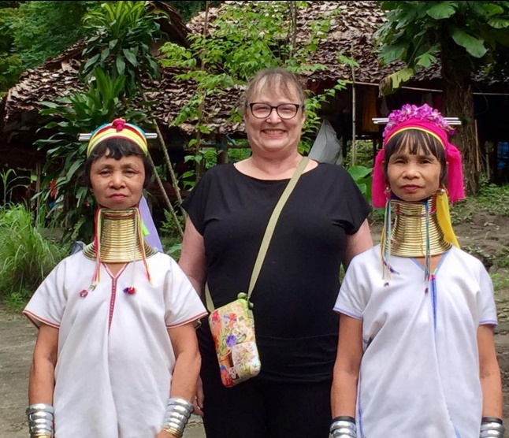
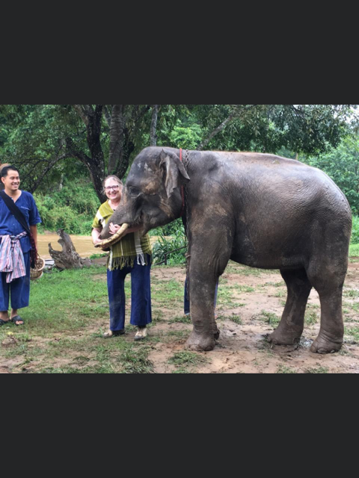

Movies to get you in the mood

https://theculturetrip.com/asia/thailand/articles/7-films-to-watch-before-visiting-thailand/

https://almostginger.com/30-films-set-in-thailand/

A little light reading to get you in the mood
﻿https://thebambootraveler.com/books-about-thailand/

https://www.tripfiction.com/ten-great-books-set-in-thailand/

Learn the language
https://learnthaifromawhiteguy.com/?gclid=CjwKCAjwqpP2BRBTEiwAfpiD-0n05VBo86BImpUksIEXGv2PAcSmvsMI_aERqD8Z1z2vcSNzO5eFJBoCkAIQAvD_BwE

https://www.fluentin3months.com/thai-learning-resources/

Learn about the wildlife
https://theculturetrip.com/asia/thailand/articles/11-amazing-animals-you-can-find-in-thailand/

Learn about the culture
You have the overall Thai culture and there are a lot of Hill Tribes which are definitely worth visiting.
https://theculturetrip.com/asia/thailand/articles/11-things-you-should-know-about-thai-culture/

Hill tribes https://theculturetrip.com/asia/thailand/articles/explore-thailands-hilltribes-before-everyone-else-does/

Now you are ready to travel virtually.

Put on some music
https://www.holidify.com/pages/music-of-thailand-2606.html

Cook up some recipes
https://www.thespruceeats.com/thai-recipe-photos-4121872

Virtual tours
https://www.youtube.com/watch?v=bXMEAsBDlBg&feature=youtu.be

https://www.tourismthailand.org/Articles/virtual-tours-thailand

https://www.bangkokpost.com/travel/1910388/virtual-tours

Here are possible tours for when the time to actually travel again arrives

Mostly, people go to Bangkok only. However, that is like going to New York City and thinking it is representative of the US. I definitely recommend going to the north to the Chiang Mai area which is where the elephants and hill tribes are. A second area is Phuket and the southern beaches and islands. Those are nice for what they are. Not really cultural, just beaches.
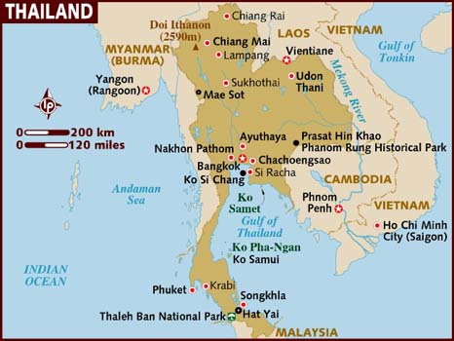

Climate
https://www.jetsetter.com/magazine/the-best-time-to-visit-thailand/

Company based in Chiang Mai
https://www.wannatours.com/programs/program-05.html

Adventure tour
https://www.intrepidtravel.com/us/thailand/highlights-thailand-125063

Regular tour
https://www.trafalgar.com/en-us/tours/t/treasures-of-thailand

Many people after the long trip over decide to also go to Cambodia, including Angkor Wat, or Laos. Laos is great because it is not overtouristed yet. Some may also add Vietnam, but I personally think that should be a different trip.

Curated resources to further prepare
https://explore.approachguides.com/45/3581/c0HLTFSu?uid=QXSBGbD5

Linda de Sosa
Bucketlist Travel Consulting,
independent affiliate of Travel Experts, a proud member of Virtuoso.

lindadesosa@ travelXperts.com 2814601090
www.bucketlisttravelconsulting.com

Prepare for stop five, Australia
Now we have hit my favorite country. I love the people, the wildlife, the geology, and the history. Do you know the aborigines arrived 50,000 years ago?

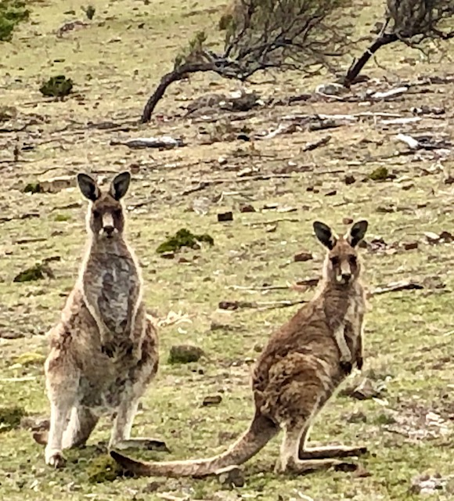

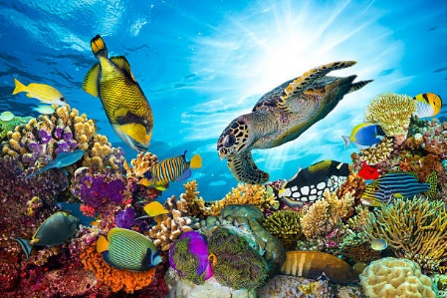

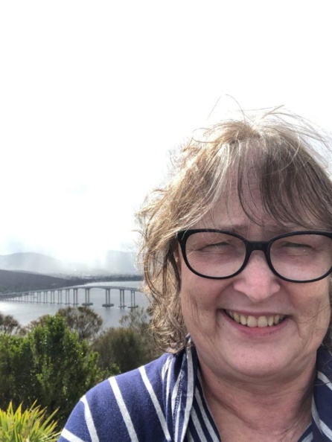

Movies to get you in the mood

There are two types of movies – movies by Australians and about Australia
My favorite movies about Australia are Thorn Birds and The Rabbit Proof Fence.

https://www.propertyguides.com/australia/news/must-watch-movies-about-australia/

https://blog.pssremovals.com/best-australian-movies/

https://www.stuff.tv/news/25-best-australian-movies-ever

https://theculturetrip.com/pacific/australia/articles/the-top-10-australian-movies-you-should-watch/

A little light reading to get you in the mood
https://www.tripfiction.com/five-great-books-set-in-australia/
Again, my favorite book is Thorn birds.

https://www.travellingbookjunkie.com/11-top-books-to-read-on-australia/

https://bookriot.com/2017/06/09/100-must-read-australian-books/

Learn the language

https://nomadsworld.com/aussie-slang/

Crossword puzzle with Aussie slang
https://www.aussiespecialist.com/en-us/sales-resources/virtual-fam-hub/virtual-qld.html

Learn about the wildlife
https://www.australia.com/en-us/things-to-do/wildlife/australias-unique-wildlife-experiences.html

Learn about the culture
Australia really recognizes their aboriginal culture. As an Aussie specialist, I have been to many meetings and they always thank the culture that owned the land where the convention center is.
https://www.everyculture.com/A-Bo/Australia.html

https://australianstogether.org.au/education/curriculum-resources/our-cultures/

OK, now you are ready.

Put on some music
You have Australian music and also indigenous music with the haunting digeridoo.
https://www.youtube.com/watch?v=nN-542IYoE0


http://www.australian-information-stories.com/music-of-australia.html

https://www.youtube.com/watch?v=FqtttbbYfSM

Cook up some recipes

https://www.thespruceeats.com/australian-food-4162464

Virtual tours
https://parksaustralia.gov.au/uluru/discover/virtual-tour/

https://www.travelpulse.com/opinions/column/armchair-travel-virtual-australia-vacation.html

https://tourismaustralia-mkt-prod1-t.campaign.adobe.com/r/?id=h1b0b96b,22deec0,210bd03&cid=DM55874&bid=28359019&p1=en-us

Tasmania
https://www.aussiespecialist.com/en-us/sales-resources/virtual-fam-hub/virtual-tas.html
Queensland Great Barrier Reef
https://www.aussiespecialist.com/en-us/sales-resources/virtual-fam-hub/virtual-qld.html

Here are possible tours when the time to actually travel again arrives
Most people do Sydney, Rock, and Reef which is the bare minimum I feel you should do. However, I just did Tasmania and it was fascinating. Perth in the west had lot of sites I would recommend. I also have done Kakadu National Park in the north and Kangaroo Island by Adelaide in the south. Both have great wildlife.

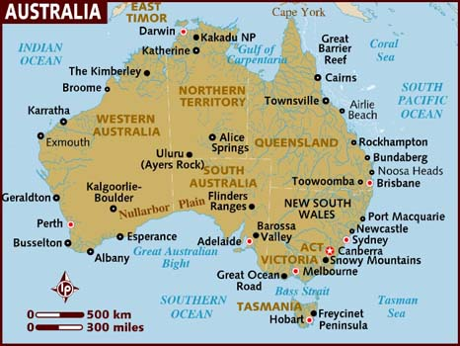
Climate – when to go
https://www.climatestotravel.com/climate/australia

Length of time
To give you perspective, Australia is the size of the continental US. You would not try to do the whole US in a week. To my mind, 2 weeks is the minimum. Three weeks if you are going to add New Zealand.

Sydney, Rock, and Reef
https://www.swaindestinations.com/australia/itinerary/8/sydney-rock-and-reef

Wildlife based tour
https://www.nathab.com/asia-adventure-travel/southern-australia-tasmania-nature-tour/
Adventure tour
https://m.expeditions.com/sellsheetscontent/GetSellSheets/?itineraryId=834

Luxury lodges
https://luxurylodgesofaustralia.com.au/

Wineries
https://www.australia.com/en-us/things-to-do/food-and-drinks/australias-best-wineries.html

Some people figure if they are going to go that far, they will include New Zealand. Keep in mind they are 4 hours apart. One way to do that is to take a cruise that travels between Auckland and Sydney. The Australian part must be supplemented by a land package because it is usually just touching the country. Most major cruise lines do this during our winter.

Curated resources to further prepare
https://explore.approachguides.com/45/1315/DncPVG5f?uid=QXSBGbD5

Linda de Sosa
Bucketlist Travel Consulting,
independent affiliate of Travel Experts, a proud member of Virtuoso.

lindadesosa@ travelXperts.com 2814601090
www.bucketlisttravelconsulting.com

Prepare for stop six, Antarctica
It’s time for everyone to finish off their bucket list. But, Antarctica is so much more than that. It is wildlife and history and being in a spot where few others have gone.

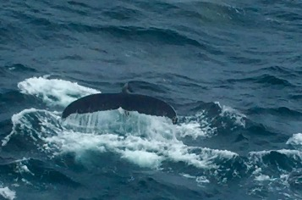
Photos to get you in the mood
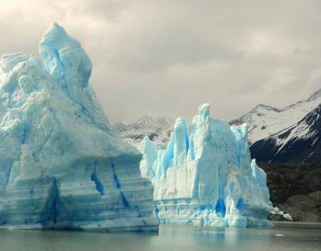
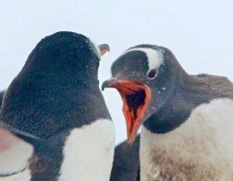

Movies to get you in the mood
https://editorial.rottentomatoes.com/article/Total-Recall-Chill-Out-With-These-Antarctica-Movies/

https://oceanwide-expeditions.com/blog/10-books-and-films-to-prepare-for-your-antarctica-cruise

A little light reading to get you in the mood
https://www.wayfairertravel.com/inspiration/books-about-antarctica/

https://www.telegraph.co.uk/travel/cruises/articles/books-for-an-antarctic-cruise/

Learn the language
Why, yes, they do speak English. But the penguins are very verbal and quite noisy.
https://www.youtube.com/watch?v=QLFqdRRqjrs

Learn about the wildlife
https://www.antarcticaguide.com/antarctica-wildlife-2/antarctica-penguins/

Learn about the culture
Could you live there?
https://www.cosmopolitan.com/lifestyle/news/a46171/keri-nelson-year-on-ice-antarctica-interview/

https://www.coolantarctica.com/Antarctica%20fact%20file/science/can_you_live_in_antarctica.php

Put on some music
https://discoveringantarctica.org.uk/introducing-antarctica/imagining-antarctica/the-sound-of-silence/

Cook up some recipes
Cheated a little here….
https://www.youtube.com/watch?v=QLFqdRRqjrs

https://www.bbc.co.uk/food/icing

Virtual tours
https://www.youtube.com/watch?v=TZwzb_866Ww

http://shackleton100.com/antarctica/

https://www.bas.ac.uk/polar-operations/life-in-the-polar-regions/virtual-tours/virtual-trip-to-antarctica/

Here area possible tours when the time to actually travel again arrives
When to travel
https://www.antarcticaguide.com/best-time-to-visit-antarctica/

This is how I went. I loved it because I have never seem more committed naturalists. They also have an option to allow you to fly over the Drake Passage, which is not for the faint of heart/
https://www.quarkexpeditions.com/antarctic/the-antarctic-peninsula

There are other expedition ships that do it and several regular cruise lines sail by it, but they may not stop.

Curated resources to further prepare
https://explore.approachguides.com/45/3982/u7WCqrFS?uid=QXSBGbD5

Linda de Sosa
Bucketlist Travel Consulting,
independent affiliate of Travel Experts, a proud member of Virtuoso.

lindadesosa@travelXperts.com 2814601090

Prepare for stop seven, Peru

I love Peru – I have been 3 times and I need at least one more visit to see all I need to see. There is Cusco, the Incan capital, the Sacred Valley and Machu Picchu. I’ve been to the Peruvian Amazon twice, once by land and once by river. There is the Colca Valley and Nazca lines. So much history and mystery.
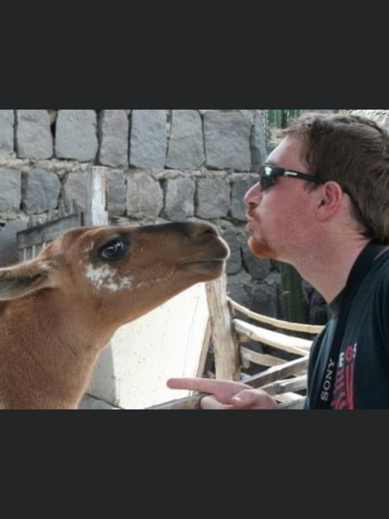

Movies to get you in the mood
https://www.projectcordillera.org/2018/11/26/top-10-movies-watch-traveling-peru/

https://theculturetrip.com/south-america/peru/articles/13-films-you-must-see-before-visiting-peru/

A little light reading to get you in the mood
https://theculturetrip.com/south-america/peru/articles/a-literary-journey-through-peru-5-essential-books/

https://medium.com/@NicolasBello/the-15-books-you-have-to-read-to-understand-peru-c0fa28b8bb1b

https://offtheshelf.com/2019/07/books-to-read-for-traveling-to-peru/

Links to some books
https://amzn.to/3e2v5gQ

https://amzn.to/2XbVAd9

https://amzn.to/3e2UqqW

Learn about the wildlife
https://www.pettitts.co.uk/blog/peru-wildlife

Learn about the culture
https://www.adventure-life.com/peru/articles/peru-overview

https://www.perurail.com/blog/all-you-need-to-know-about-the-inca-culture/

Learn the language
https://theculturetrip.com/central-america/articles/the-best-apps-for-learning-spanish-before-a-trip-to-latin-america/

Now you are ready to go!

Put on some music
https://theculturetrip.com/south-america/peru/articles/an-introduction-to-peruvian-music-in-12-songs/

Cook up some recipes
https://matadornetwork.com/read/15-peruvian-foods-delicious-theyll-blow-mind/

Virtual tours
https://www.travelandleisure.com/trip-ideas/peru-virtual-tours

https://www.travelpulse.com/opinions/column/armchair-travel-adventure-in-machu-picchu.html

Here are some possible tours when the time to actually travel again arrives

When to travel
https://www.frommers.com/destinations/peru/planning-a-trip/when-to-go
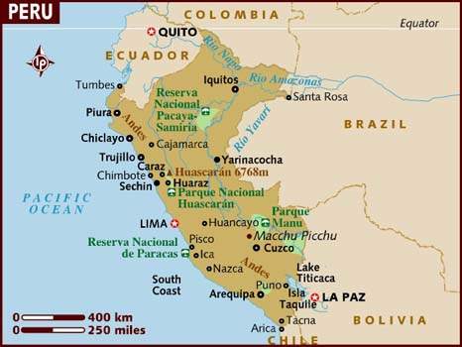

Tours
https://www.belmond.com/itineraries/south-america/best-of-peru

https://www.abercrombiekent.com/tours/luxury-small-group-journeys/2021/machu-picchu-sacred-valley

Amazon
https://www.nathab.com/south-america/amazon-river-cruise/

Many people also combine Machu Picchu with the Galapagos, like this
https://www.abercrombiekent.com/tours/luxury-small-group-journeys/2021/wonders-of-the-galapagos-and-machu-picchu-eastern-islands

Curated resources to further prepare

https://explore.approachguides.com/45/1324/pHv9KKtm?uid=QXSBGbD5

Linda de Sosa
Bucketlist Travel Consulting,
independent affiliate of Travel Experts, a proud member of Virtuoso.

lindadesosa@travelXperts.com 2814601090
bucketlisttravelconsulting.com

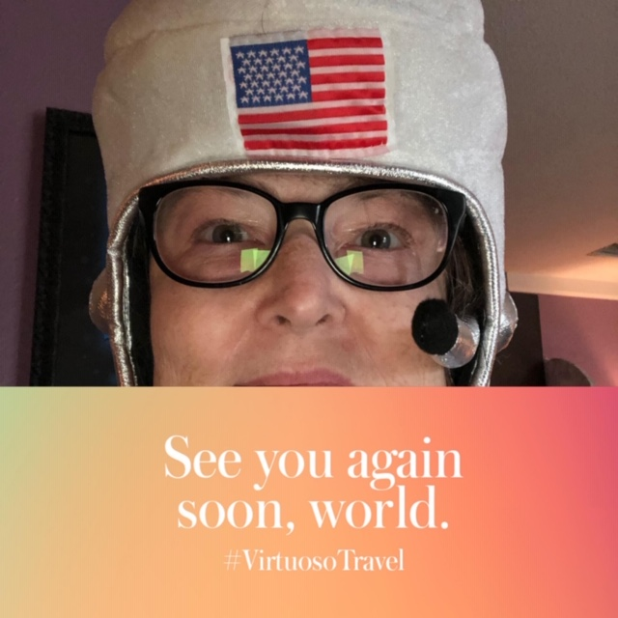

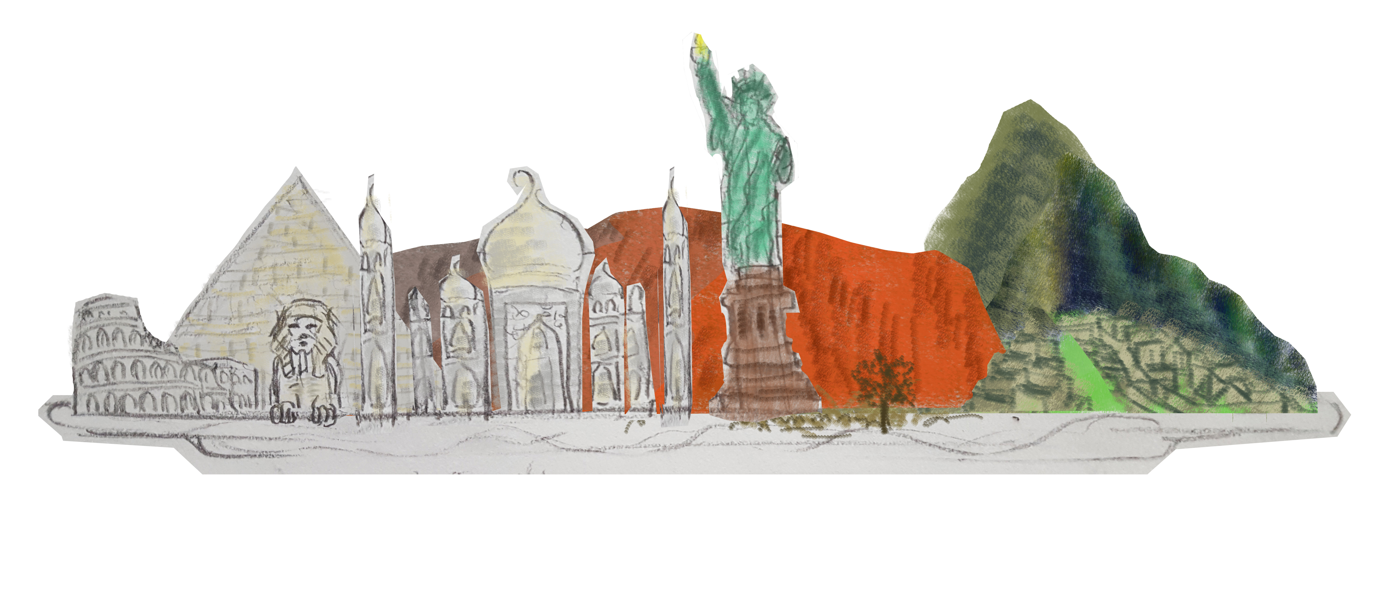
Love. Ingenuity. Spirituality. Power. Immortality. Hope.

